**“Nursery Management System”**

**SUBMITED BY**

1. Niket liladhar Bhangale.

2. Megharaj lalit Narkhede



**Department Of Computer Application.**

**K.K.Wagh Arts, Commerce, Science and Computer Science College.**

**Nashik-422003**

**Academic Year 2022-23**



Karmaveer  Kakasaheb Wagh Education Society’s

**K. K. Wagh Arts Commerce, Science, & Computer Science College**

**Saraswati Nagar Nashik-422003**

**C E R T I F I C A T E**

This is to certify that,

**Mr**. **Niket Liladhar Bhangale & Megharaj Lalit Narkhede**

has satisfactory completed his/her/their project **“Nursery Management** **System”** as fulfillment in **T.Y.B.B.A.(Computer Application)** Class for the academic year **2022-2023**.

Project Done by: 1 Niket liladhar Bhangale

2. Megharaj lalit Narkhede

Prof .V.H.Bava

Project Guide                                                             H.O.D

Internal Examiner                                                 External Examiner

**Index - Website Project**

|  |  |  |
| --- | --- | --- |
| **Sr. No** | **Documentation Content** | **Page No** |
| **I** | **Introduction** | |
| 1 | Motivation | 1 |
| 2 | Problem Statement | 2 |
| 3 | Purpose / Objective and Goals | 3 |
| 4 | Literature Survey | 4 |
| **II** | **System analysis** | |
| 1 | Existing Systems | 5 |
| 2 | Scope and Limitations of Existing Systems | 6 |
| 3 | Project Perspective , Features , Stakeholders | 7-8 |
| 4 | Requirement Analysis -  Functional requirements, Performance requirements,  Security requirements etc | 9 |
| **III** | **System Design** | |
| 1 | Class Diagram | 10 |
| 2 | Use Case ,Activity Diagram , Sequence Diagram  , Deployment Diagram | 11-15 |
| 3 | User Interfaces | 16-17 |
| **IV** | **Implementation details** | |
| 1 | Software / Hardware Specifications | 18 |
| **V** | **Outputs and Reports Testing** | |
| 1 | Screenshot and Report | 19-26 |

**Motivation**

We own our sincere gratitude to all those people who have given us their constant support and encouragement without which our project report would not have reached this stage.

                     We would like to express our thanks to Prof V.H Bava , Prof V. P. Hiray for  her advice and encouragement. She has been a pillar of strength right through the project till the preparation of this report and helped by boosting morale, so we could surmount the difficulties that came across during completion of this project.

                    We would like to express our gratitude to Dr. S.V. Patil , Principal, K.K.Wagh Arts, commerce, science and Computer Science College and Prof.Vijayshri Bava, Head of Computer Application department for the support and the infrastructure they have provided, so that we could successfully complete the project on time.

                  Last but not the least, we would like to express our sincere thanks to all staff members and our friends for their help and cooperation in all phases of the project.

1. Niket liladhar Bhangale

2. Megharaj lalit Narkhede

1

Problem Statements:-

There are a lot of websites on the internet whereby it offers a variety of products and services for consumers to find and buy through online such as plants and more Moreover, the online also provides some of the services which is paying bills online, and more. In this research, we are looking at the problem addressed in this research which is the view of online shopping by consumers.

However, there are several reasons hinder in the consumer are involved in online shopping because some of the consumers are not willing to take part in online purchased due to the valid reason because there are worried about the quality of the product in online are not durable, moreover, there are not confident.

2

Purpose Objectives/Goals:-

The purpose behind development of this project is to provide an easy way to get the marketing rates. It is an excellent feature for the users.

Now a day’s Internet has become a medium of communication that’s why we develop this Website Web sites play an important role. To update the records of products rates of many types of plants . This is a very time consuming system for us.

The main objective of the project is to establish a network among the people residing in all over the world by which all the information related to products and any new updates can be easily accessed and shared among the people

· New user registration.

· Purchaser registration.

· Product and Registration.

· Various types of products are buying.

· On our website details of products are available on the website.

· Available Quantity of product into Market is displayed.

· Export the product.

. Update the details of product rates.

3

Literature Review:-

This chapter will mainly discuss on the study that are done by previous research of other authors in the similar area of the present study. Throughout this chapter, there will be comprehensive discussion on theoretical and practical views of previous studies done in online shopping and offline shopping for apparels. This study combines factors that other studies have done that will influence the consumer’s purchasing decision in online and offline stores for apparels. It includes the price attractiveness, time saving, perceived risk, enjoyment and excitement, tangibility and high interactivity. All of these factors will contribute to the study of customer’s purchasing intention for apparels on both stores which includes online and offline shopping. Pan, (2007) defined purchasing intention as the eagerness of purchasing the product. Similarly, Engel, Blackwell and Miniard, (1990) defines purchasing intention as a psychological process of decision-making. In online shopping, it is expected that shoppers are more likely to associate price attractiveness and time saving with their intention to shop while in offline shopping, consumers are more likely to associate tangibility, high interactivity and enjoyment with their intention to shop.

4

Existing System:-

In the existing system all transactions, dealings of products, purchasing of products was done manually which is time consuming.

Reports are prepared manually as and when needed. Maintaining reporting is a very tedious task.

To buy any product, the user has to collect information about it either by visiting the shop or asking people which is the better one.

There is no computer system for handling payments. All calculations are performed manually which may not always be accurate. Maintaining the record is really a tedious task.

Any internet user can use this existing website to search for any kind of products, select particular products from a wide range of products.

Once they make up their mind to purchase any particular thing they can place an order and make a payment through various available payment options.

5

SCOPE:-

This system provides assurance of proper accuracy and effectiveness thereby improving the related services.

This system provides better management by providing desired flexibility, fast responsibility, to support changes and ability to maintain quality services.

Since this system has very sensitive information within it stored in the database we have tried to provide the maximum security.

We are going to develop the proposed system within an objective to eliminate the running cost by overcoming the continuous expenses, manual storage needs and extra staff in the information resource department of the organization.

We have tried to develop this system keeping in mind the user of the system. So, there is not much need for a trained professional to use this system.

LIMITATIONS:-

System is not a multi-user system.

Data loss can occur due to technical issue so it is necessary to make backups at regular intervals of time.

Initially, it may seem to be a costly investment but eventually it is profitable as it saves money on manpower, materials, etc.

6

Feasibility Study:-

After doing the project, study and analyze all the existing or required functionalities of the system, the next task is to do the feasibility study for the project. All projects are feasible - given unlimited resources and infinite time. Feasibility study includes consideration of all the possible ways to provide a solution to the given problem. The proposed solution should satisfy all the user requirements and should be flexible enough so that future changes can be easily done based on the future upcoming requirements.

Economic Feasibility:-

This is a very important aspect to be considered while developing a project. We decided the technology based on the minimum possible cost factor. All hardware and software cost has to be by the organization.

Technical Feasibility:-

This included the study of function, performance and constraints that may affect the ability to achieve an acceptable system. For this feasibility study, we studied complete functionality to be provided in the system, as described in the System Requirement Specification (SRS)and checked if everything was possible using different types of frontend and backend platforms.

7

Features:-

The system is very simple in design and to implement. The system requires very low system resources and will work in almost all configurations.

· User friendly application

· Open source application

· Simple coding techniques

· Easy maintenance

· Fast processing and handy

· Data can be updated easily

· Database records can be maintained in computer

· Easy Data Retrieval

· System reduces manual workload

· Redundancy of data is avoided

· Provide reports of data

8

REQUIREMENT ANALYSIS:-

Functional Requirements

1.Customer Module

• Customer can view products without login.

• When customer try to purchase product, then he must login to system.

• Customer can save their product in wish list.

• Customer can see every detail.

2.Admin Module:

• Admin can provide username, email, password and your admin will be created.

• After login, there is a dashboard where admin can see how many customers is registered, how many products are there for sales, how many orders placed.

• Admin can add, delete, view, edit the products.

3.Performance Requirement:

• Availability: The system should remain operational in any day and any place.

• Accuracy: There is a need to optimize the system to ensure more accurate results.

• Usability: The System should provide a User-Friendly user interface and tooltips to enhance itself and be effectively responsive.

9

Class diagram

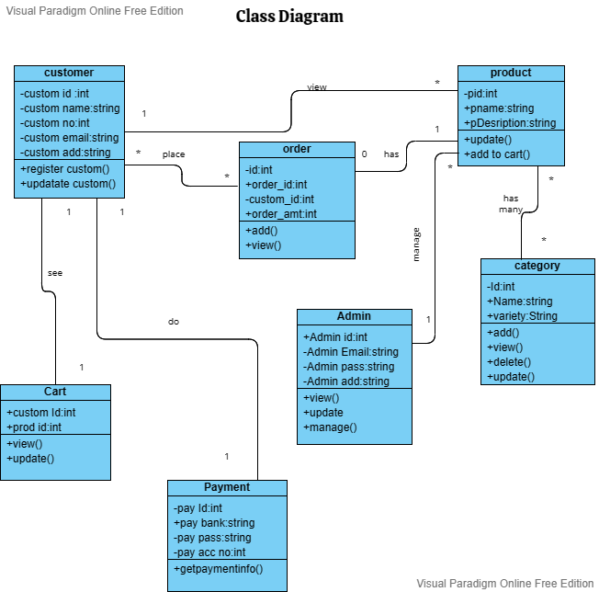

10

Use case:-

Login

Check the orproduct

Select the order

Place the order

Receive the order

Payment

Give the order

Logout

Admin

Customerererer

11

Activity Admin:-

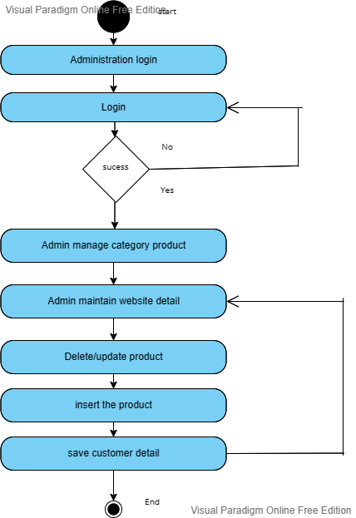

12

Activity Customer:-

13

Sequence diagram:-

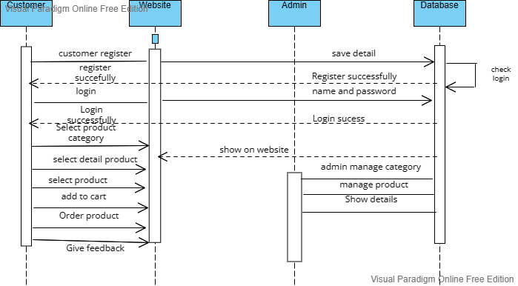

14

Deployment Diagram:-

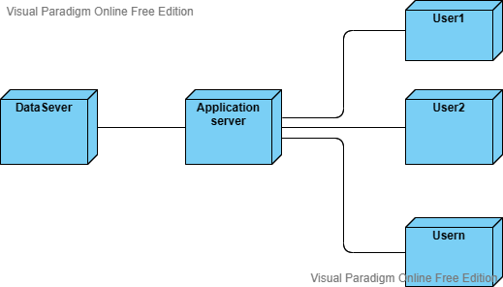

15

Data dictionary:-

Admin Table :-

|  |  |  |
| --- | --- | --- |
| **Field** | **Type** | **Key** |
| adminid | integer | Primary key |
| adminuserName | varchar | Not null |
| adminPassword | varchar | Not null |

Plant Table :-

|  |  |  |
| --- | --- | --- |
| **Field** | **Type** | **Key** |
| plantid | integer | Primary key |
| commonName | varchar | Not null |
| typeofplant | varchar | Not null |
| plantDiscription | varchar | Not null |
| plantCost | double | Not null |

16

Customer Table :-

|  |  |  |
| --- | --- | --- |
| **Field** | **Type** | **Key** |
| customerid | integer | Primary key |
| customerName | varchar | Not null |
| customeremail | varchar | Not null |
| UserName | varchar | Not null |
| Password | varchar | Not null |
| Address | Address | Not null |

Order table :-

|  |  |  |
| --- | --- | --- |
| **Field** | **Type** | **Key** |
| bookingorderid | integer | Primary key |
| orderdate | date | Not null |
| transactionMode | varchar | Not null |
| quantity | integer | Not null |
| totalCost | double | Not null |

17

Software Requirement:-

|  |  |
| --- | --- |
| Operating system | windows 10 |
| Browser | Microsoft edge |
| Database | MYSQL |
| Scripting language used | Html, CSS, php |

Hardware Requirement:-

|  |  |
| --- | --- |
| Processor | Intel 11th Generation Intel core i3 |
| Ram | 8GB |
| Hard disk | 512GB |
| Monitor | 15 color monitor |

18

Screenshots: -

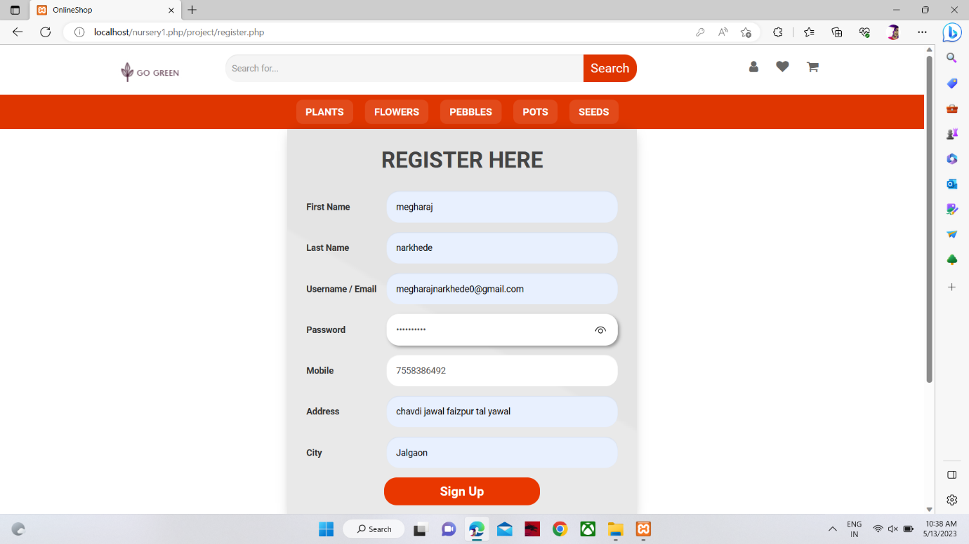

Login page

19

Home page

All product

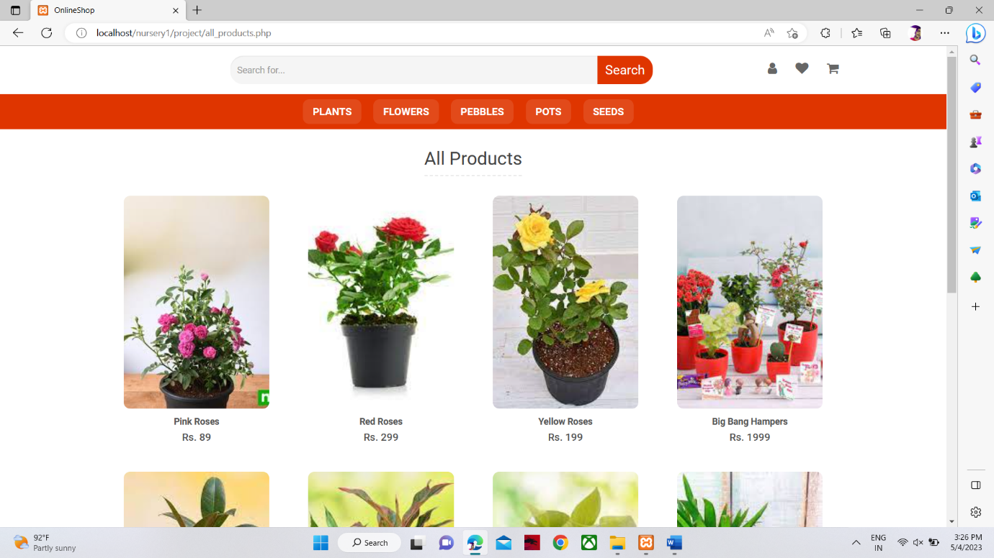

20

Popular products

Plants

21

Flowers

Pebbles

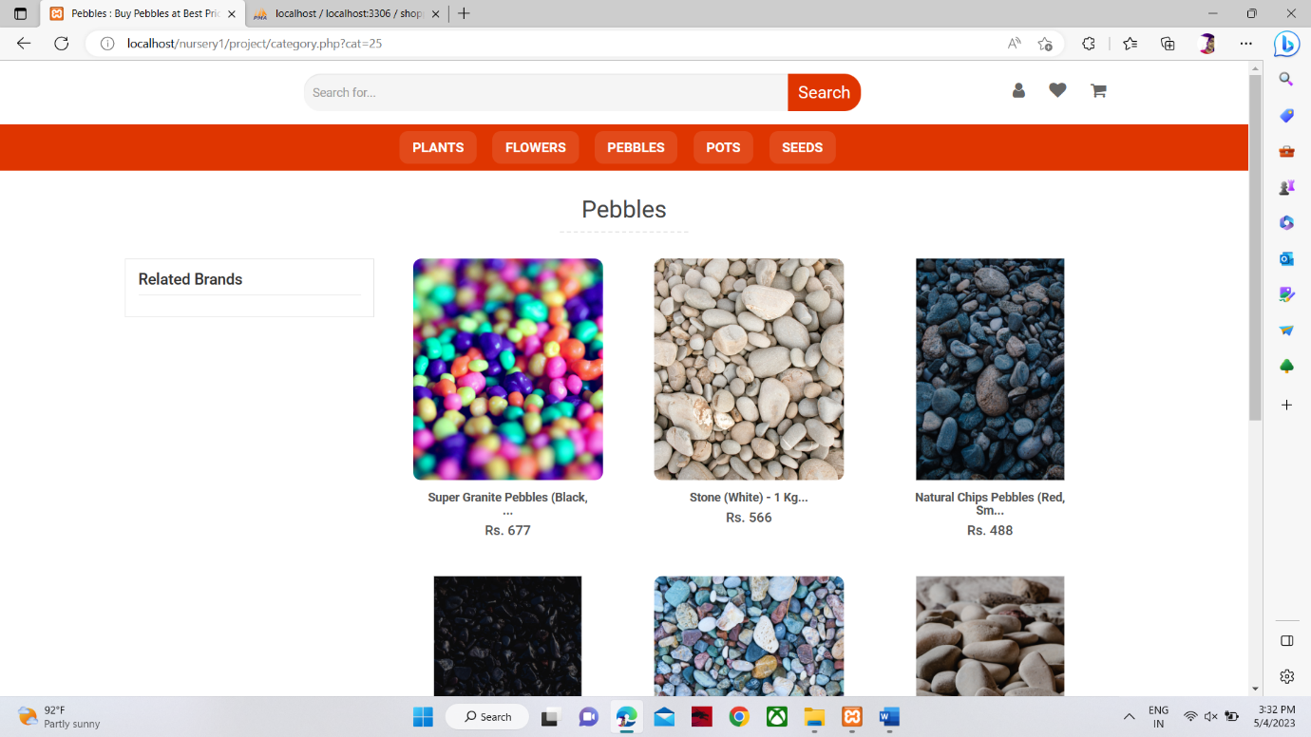

22

Pots

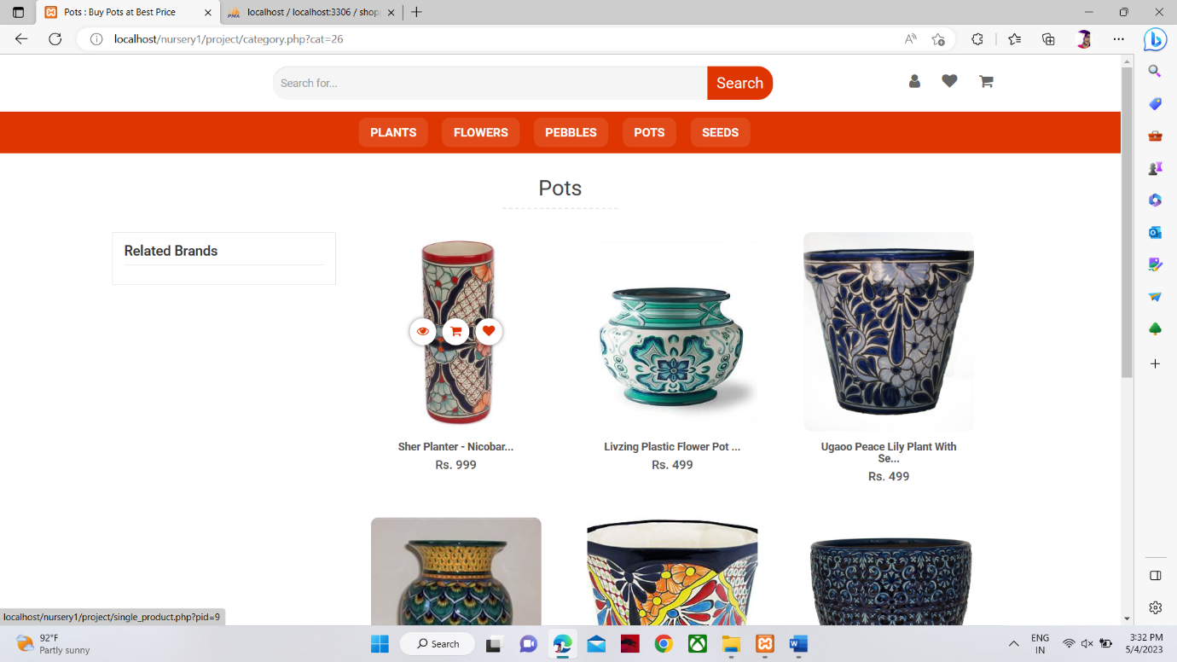

Seeds

23

Product details

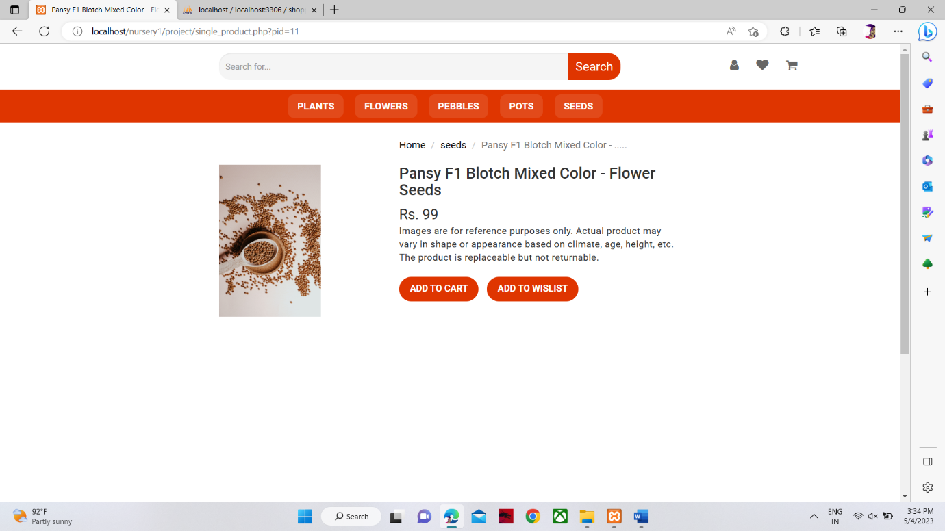

My cart

24

Payment

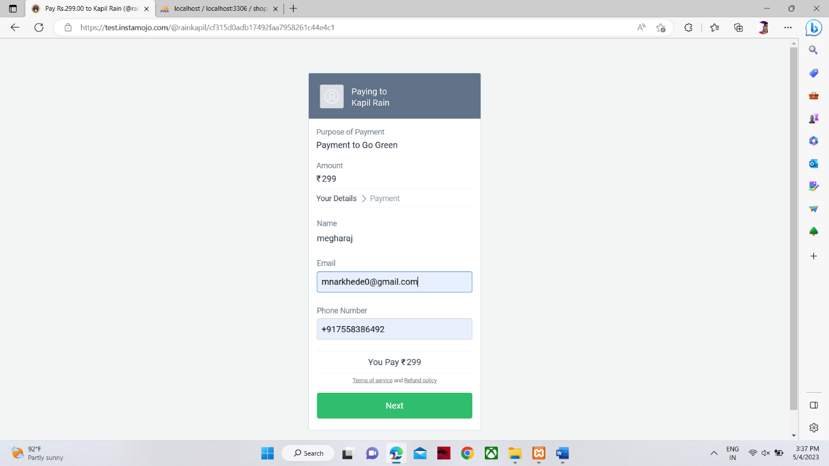

Orders

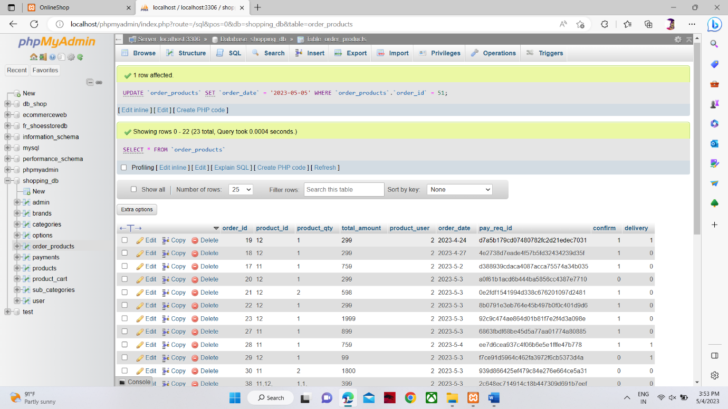

25

Conclusion:-

* Performance gain and better control of the system.
* The system can maintain large volumes of data easily.
* The processing is faster as compared to manual system.
* Reduction in access time & efforts involved.
* System is less expensive & accurate as compared to manual system.
* It produces timely reports & output.
* Volume of manual information registers are avoided reducing papers work.
* It provides improved& efficient services.

26